Summary of the first outcome

File Extension: A file extension, also called a file format, is the layout of a file – in terms of how the data within the file is organized.

Why Are File Extensions Used?

It tells the computer how to display or process its content. Common file formats include CSV, XLSX, ZIP, HTML, PDF, TXT, etc.

Text: There are many text file formats, such as CSV, XLSX, TXT, HTML, and PDF

_____________________________________________________________________________

Comma-separated values (​​CSV):is a text file with a specific format that allows data to be saved in a table-structured format.

Open a CSV File: a) Microsoft Excel:

b) Python Code:

Read CSV file using Python:

import pandas as pd

test=pd.read_csv(r"C:\Users\Abdo Schofield\Desktop\test.csv")

print(test)

_____________________________________________________________________________Microsoft Excel Open XML Spreadsheet (XLSX): It is a file with the XLSX extension used in Microsoft Excel, which uses tables to organize, analyze, and store data

Open an XLSX File: a) Microsoft Excel:

b) Python Code:

Read XLSX file using Python:

!pip install xlrd

import pandas as pd

test=pd.read_excel(r"C:\Users\Abdo Schofield\Desktop\test.xlsx")

print(test)

Text File (TXT): A file with a .txt extension is a text file used to store simple text documents or data sets.

Open a TXT file: a) Notepad:

b) Python Code:

Read TXT file using Python:

test= open(r"C:\Users\Abdo Schofield\Desktop\test.txt","r")

print(test.read())

#output:

Python

CSV

HTML

Java Script

CSS

print(test.readline())

#output:

Python

for x in test:

print(x)

#output:

Python

CSV

HTML

Java Script

CSS

_____________________________________________________________________________JavaScript Object Notation (JSON): is a plain text format written in JavaScript object notation and it is used to send data between computers.

Open a JSON File: a) Notepad:

b) Python Code:

Read JSON file using Python:

import json

json_file=open(r"C:\Users\Abdo Schofield\Desktop\test.json",”r”)

data = json.load(json_file)

print(data) OR print(data[“حاجة معينة جوه الملف”])

____________________________________________________________HyperText Markup Language (HTML): It is the language used to create web pages. OR It is a markup language used to describe the structure of information on a web page

Open an HTML File: a) Notepad:

b) Python Code:

Read HTML file using Python:

import codecs

from bs4 import BeautifulSoup

test= codecs.open(r"C:\Users\Abdo Schofield\Desktop\test.html",'rb')

data = BeautifulSoup(f.read()).get_text()

print(data)

OR

import codecs

from bs4 import BeautifulSoup

test= codecs.open(r"C:\Users\Abdo Schofield\Desktop\html.html",'r')

data = BeautifulSoup(f, 'html.parsester')

print(data.find('h1'))

___________________________________________________________________Extensible Markup Language (XML): is markup language used to both people and machines to read easily

Open an XML File a) Notepad:

b) Python Code:

Read XML file using Python:

from bs4 import BeautifulSoup

test = open(r"C:\Users\Abdo Schofield\Desktop\test.xml", "r")

x =file.read()

data = BeautifulSoup(x, 'xml')

print(data.find('book').get_text())

___________________________________________________________________Portable Document Format (PDF): a file that preserves the format and appearance of documents on any device

Open a PDF file: a) PDF reader:

b) Python Code:

Read PDF file using Python:

!pip install PyPDF2

import PyPDF2

sample_pdf = open(r'C:\Users\2041\Desktop\data.pdf','rb')

pdfdoc = PyPDF2.PdfReader(sample_pdf)

print(len(pdfdoc.pages)) OR print(pdfdoc.pages[15]) OR print(pdfdoc.pages[16].extract_text())

String Manipulation : String manipulation is the process of modifying strings

**The most common functions of string manipulation in Python.**

1. len(): It returns the length of a string.

2. capitalize(): It converts the first character of a string to uppercase and the rest to lowercase.

3. casefold(): It converts a string to lowercase and removes all case distinctions in the string.

4. center(): It returns a centered string padded with a specified character where the first parameter is the max length and the second is the required padding character.

5. count(): It returns the number of occurrences of a specified substring in a string.

6. endswith(): It returns True if a string ends with a specified suffix, otherwise False.

7. Concatenation: To join two or more strings together, you can use the “+” operator or the join() method.

8. Substring Extraction: To extract a portion of a string, you can use indexing and slicing. Indexing starts at 0 and goes up to the length of the string minus one. Slicing is done using a colon (:).

9. find(): It returns the index of the first occurrence of a specified substring in a string, or -1 if not found.

10. index(): It returns the index of the first occurrence of a specified substring in a string, or raises an exception if not found.

11. isalnum(): It returns True if all characters in a string are alphanumeric, otherwise False.

12. isalpha(): It returns True if all characters in a string are alphabetic, otherwise False.

13. islower(): It returns True if all characters in a string are lowercase, otherwise False.

14. isnumeric(): It returns True if all characters in a string are numeric, otherwise False.

15. isspace(): It returns True if all characters in a string are whitespace, otherwise False.

16. istitle(): It returns True if the string is in title case (the first character of each word is uppercase), otherwise False.

17. Case Conversion: To convert the case of a string, you can use the upper() or lower() method.

18. String Formatting: To format a string, you can use the format() method or f-strings.

___________________________________________________________________

Converting Text Files from One Format to Another

1. From CSV to Excel and Vice Versa:

import pandas as pd

data = pd.read_csv(r'C:\Users\Abdo Schofield\Desktop\test.csv')

data.to_excel(r'C:\Users\Abdo Schofield\Desktop\test.xlsx')

import pandas as pd

data = pd.read_excel(r'C:\Users\Abdo Schofield\Desktop\test.xlsx')

data.to_csv(r'C:\Users\Abdo Schofield\Desktop\test.csv')

2. From TXT to CSV and Vice Versa:

import pandas as pd

data= pd.read_csv(r"C:\Users\Abdo Schofield\Desktop\test.csv")

data.to_csv(r"C:\Users\Abdo Schofield\Desktop\test.txt")

import pandas as pd

data= pd.read_csv(r"C:\Users\Abdo Schofield\Desktop\test.txt")

data.to_csv(r"C:\Users\Abdo Schofield\Desktop\test.csv")

3. From Json to TXT:

import pandas as pd

data= pd.read_json(r"C:\Users\Abdo Schofield\Desktop\test.json")

data.to_csv(r"C:\Users\Abdo Schofield\Desktop\test.txt")

3. From HTML to TXT:

import pandas as pd

test = pd.read_html(r"C:\Users\ Abdo Schofield \Desktop\test.html")

test[0].to_csv(r"C:\Users\ Abdo Schofield \Desktop\test.txt", index=False)

___________________________________________________________________

Image: All computer vision applications are based on image processing. So, it is necessary to know different images and how to deal with them. Most images are 3-Dimensional, having RGB (Red-Green-Blue) values

Common Image Format:

a) TIFF (.tif, .tiff):

TIFF stands for (Tagged Image File Format) doesn’t need to compressed, allowing for high-quality images but they are larger in size.

1. Compression: no need for compression. Very high-quality images.

2. Best for high-quality prints, and professional publications.

3. Special attributes: it can be transparent.

b) JPEG (.jpg, .jpeg):

JPEG stands for (Joint Photographic Experts Groups) is compressed to make a smaller file which causes a loss in quality (not very noticeable). JPEG files are very common and they are a popular format for digital cameras - making it ideal for web use and non-professional prints.

1. Compression: some file information is compressed or lost.

2. Best for web images, non-professional printing, email, and PowerPoint.

3. Special attributes: the amount of compression can be chosen when saving in image

editing programs like Adobe Photoshop or GIMP.

c) PNG(.png):

PNG stands for (Portable Network Graphics) is a file designed to improve and replace the GIF format. PNG files can handle up to 16 million colors, unlike the 256 colors supported by GIF.

1. Compression: compression without loss of quality is best for web images.

2. Special attributes: it can be transparent.

___________________________________________________________________

Digital Image Processing (DIP):

Digital Image Processing (DIP): is the manipulation and analysis of digital images using computer.

a) Color systems:

In digital images, colors are represented using different color systems. The most common

Ones are RGB (Red-Green-Blue), CMYK (Cyan-Magenta-Yellow-Key/Black),

And HSV (Hue-Saturation-Value).

RGB is used for displaying images on a screen, while CMYK is used for printing

b) Pixels:

The smallest unit of an image is called a pixel. A pixel represents

a single point in the image and contains information about its color and brightness.

The number of pixels in an image determines its resolution.

c) Arrays:

A digital image can be thought of as a 2D array of pixels. Each pixel is represented by a value or set of values, depending on the color system used.

d) Image acquisition:

This involves capturing an image using a digital camera, scanner, or another device.

e) Image enhancement:

This involves improving the quality of an image by applying various techniques such as

contrast enhancement, noise reduction.

f) Image filtering:

Image filtering is a technique used to modify the appearance of an image. Filters can be used

to smooth the image, enhance certain features, or remove noise.

g) Image compression:

used to reduce the size of the image file without affecting its quality. that

It is used to save storage space and reduce transmission time in applications such as video streaming

And satellite photography.

h) Image restoration:

It is to restore the image that has been degraded due to various factors such as noise, or incomplete data

i) Edge detection:

that involves identifying edges in an image, an edge is defined as a sudden change the intensity.

j) Image analysis:

This involves dividing an image into multiple segments, each representing a distinct object or region of interest. It is used in applications such as object recognition and tracking.

l) Object recognition:

This involves identifying objects in an image and recognizing their shapes, sizes, and positions.

m) Morphological processing:

This involves analyzing the shape and structure of objects in an image using mathematical morphology techniques.

Computer Vision Fundamentals:

Computer vision is a field focused on enabling computers to interpret and understand digital images and videos.

1. Image processing:

This involves techniques for enhancing digital images, such as filtering, segmentation, and edge detection.

2. Feature Extraction:

It is the process of identifying and extracting important features from an image.

3. Object recognition and detection:

This involves identifying and localizing objects within an image or video stream.

4. Image classification:

This involves categorizing images based on their content.

5. Tracking:

This involves identifying and tracking the movement of objects within an image or video stream.

6. Scene reconstruction:

This involves creating a 3D model of a scene or object from a set of 2D images or video frames.

7. Machine learning and deep learning:

These are techniques that involve training algorithms to automatically learn features from visual data.

8. Augmented reality:

This involves overlaying digital content onto the real world. Computer vision techniques are used to track the position and orientation of a camera in real-time, allowing digital content to be placed and rendered in a realistic way.

___________________________________________________________________

How to Deal with Images:

1. Pillow/PIL:

From PIL import Image

Df=Image.open(r” C:\Users\Abdo Schofield\Desktop\EX.jpg”)

Df.show()

Python Code for Converting image Files:

From PIL import Image

Df=Image.open(r” C:\Users\Abdo Schofield\Desktop\EX.jpg”)

Df.save(r” C:\Users\Abdo Schofield\Desktop\EX.png”))

___________________________________________________________________

Audio: A computer system can store digital audio data in an audio file format. The audio file usually contains a very large number of bits, which in turn produces very large files. Accordingly, these files can be either uncompressed or compressed to reduce file size. Usually, data compression in audio files results in losing some data. The audio files are classified into compressible and uncompressible file formats.

There are many types of audio files, but these are two of the most common files: 1-MP3 audio format (lossy compression format).

2-WAV audio format (uncompressible format).

MP3 (MPEG-1 Audio Layer 3): is a standard format for compressing audio into a very small file.

Waveform Audio File Format (WAV): Waveform Audio File Format (WAV) is an audio file format, used to store raw audio bit streams on computers.

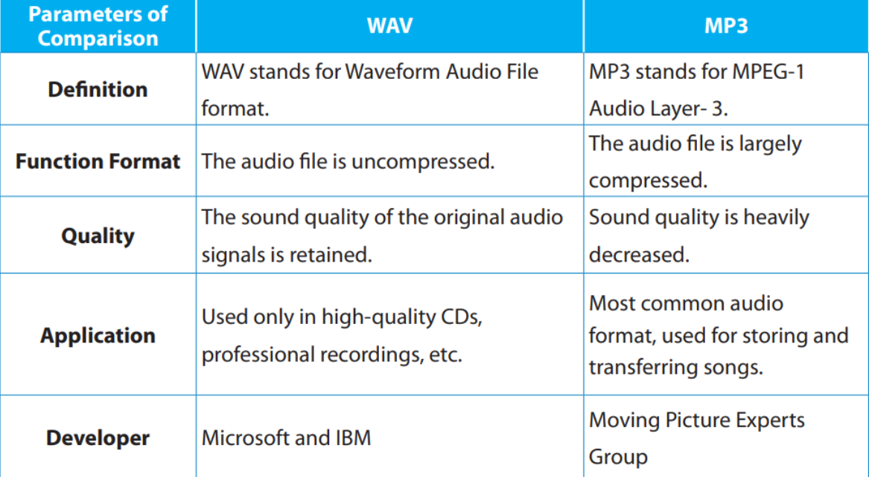

How to Deal with audios:

IPython library:

From IPython.display import Audio

Audio(r” C:\Users\Abdo Schofield\Desktop\EX.mp3”))

Python Code for Converting Audio Files:

!pip install ffmpeg

!pip install pydub

Import subprocess

Subprocess.call([“ffmpeg”,”-i”, r” C:\Users\Abdo Schofield\Desktop\EX.mp3”, r” C:\Users\Abdo Schofield\Desktop\EX.wav”])

___________________________________________________________________

Video: It is a container that can contain audio and video data in separate audio and video encoding formats. It has specific formats for saving digital video on the computer.

MPEG-4 Part 14 (MP4): MP4 is a popular video file format that allows you to store a lot of video and audio in a smaller file size.

Metal Oxide Varistor (MOV): MOV is a video format that can contain many formats such as video, audio, video and text.

Audio Video Interleave (AVI): AVI files can contain audio and video data in a file container that allows audio to be played synchronized with the video. Like the DVD video format, AVI files support multiple audio and video streaming

Matroska Video (MKV): MKV videos are container files that support unlimited image, audio and subtitle tracks. They are similar to MOV and AVI files, except they have much more storage space. It is an all-in-one video format.

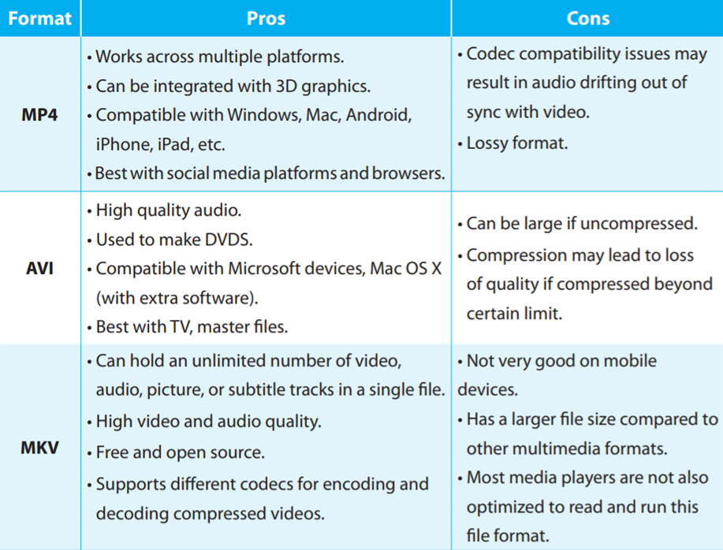

Python Code for Reading Video Files:

import cv2

v=cv2.VideoCapture(r"path file")

ret, frame = v.read()

fr=cv2.resize(frame,(720,480))

cv2.imshow('Name window',fr)

Python Code for Converting video Files:

!pip install ffmpeg

!pip install pydub

Import subprocess

Subprocess.call([“ffmpeg”,”-i”, r” C:\Users\Abdo Schofield\Desktop\EX.mp4”, r” C:\Users\Abdo Schofield\Desktop\EX.AVI”])